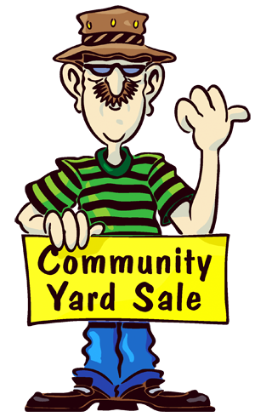

Tips for a Successful Yard Sale

If you don’t want to mark each item you can color code your items with a little stickers and create a chart, example: all items will blue stickers are .50, items with red stickers $1 and so on. Make it easy for yourself to total items - price things evenly: .25, .50 and $1.
How much money should I start off with? Well that depends. If you have a lot of small, low priced items, I think around $80 - $100 is a good number. (two $10 bill, four $5 bills, 25 $1 bills, 1 roll of quarters ($10).
Most hard-core yard sale scavengers will start looking around 7:00a.m. so keep this in mind when you are setting up. It may be best to organize things in the house and then bring them out.
Consider putting half-used batteries in something that needs batteries.
Wearing a fanny pack or carpenter's apron is recommended so you'll always have your money with you.
Have plastic grocery bags available to put sold items in.
Arrange books, CDs, DVD’s and videotapes in a box so the customers can easily read the titles.
Clean your items but don’t spend hours cleaning something that is going to sell for $1.
If you are sports balls, most suggest filling them with air.
Hang clothes if possible. A large box or tarp filled with clothes won’t make them sell as well. You may consider a tub or box and then have “baby clothes - $0.50 each.”
Mark the measurements for things like curtains and drapes, sheet sizes (twin, double, etc.). You can do this on masking tape.
Bundle things together either in a shoe box and sell the entire box or with a rubber band and sell the set.
South Four Corners Community Yard Sale
April 21, 2012
8-11a.m.
*set up in your front yard

If your kids are going to be there have them set up their own table with a goal in mind of either getting something new. It’s also great to plan ahead with them that afterwards they can donate their unsold toys to charity so that will benefit children in need.
You may want to sort the small toys and put them in sealed clear plastic baggies according to type of toy. Then STAPLE the bags closed so customers can't open them and a set price for the entire bag.
If you’re selling electrical items, have an extension cord handy so that people can test them. No smart person is going to just take your word that your television “works great”. They’re going to want to see it in operation. Also, you may want to have some batteries on hand so that a prospective buyer can test that old handheld game for himself.

